**CONTROL ENVIRONMENT MONITORS**

**User Manual**

**Overview**

This User Guide provides you with all the information you need to get the most from your control environment monitor units.

Before you begin you will need to set up the sensor units and display unit. Follow the simple instructions in ‘Getting Started’ on the next few pages.

**IMPORTANT**

Do not open or do any service inside the sensor units or display unit. Contact an agent from our company as soon as possible if a technical issue occurs

Got Everything?

The bundle product includes the following:

1. Three sensor units inclusive of the following sensors in each.
   1. Temperature and relative humidity sensor
   2. Light intensity sensor
   3. Soil moisture sensor
2. Display unit with fixed key pad, LCD screen and the alarm system
3. Two 9V batteries
4. Extra set of connectors needed for services

Need Help?

If you have any problems setting up or using your product, please contact the Customer Services using 1356.

1. Getting Started………………………………………………………………………………………………………………………………
2. Getting Know your product…………………………………………………………………………………………………………….
3. Using the product ………………………………………………………………………………………………………………………..

Sensor Unit

1. Switch the Sensor unit on/off

Display Unit

1. Switch the display unit on/off
2. Setting the Thresholds
3. Setting the alarm on/off
4. Getting the data on to the micro SD
5. Displaying the values received on the LCD Screen
6. **Getting Started**

*Location*

You need to place the sensor units inside of the control environment that need to be monitored. The display unit should be placed outside of the control environment as required by the user within 3m radius. Otherwise the interferences may cause errors in the values read inside the control environment.

*Setting up*

Both the sensor unit and the display unit work with DC power*.* ***DO NOT CONNECT ANY AC POWER ADAPTERS TO THE UNITS.*** Recommended battery voltage is 9V but can use up to 12V.

Installing the sensor unit

1. Turn the battery lever down and remove the battery cover form the back of the sensor unit and insert either rechargeable or non-rechargeable rectangular shaped 9V battery. Please ensure that the battery is properly connected to the correct terminals.

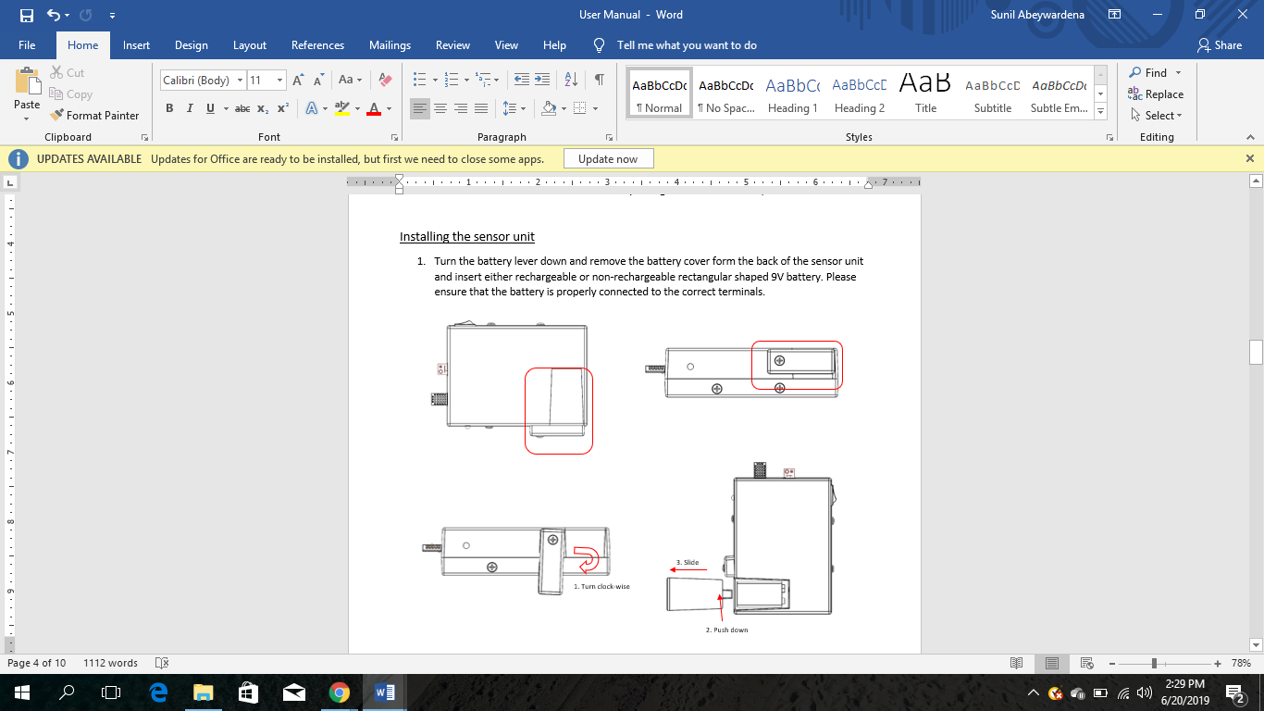

1. Slide the battery cover back into the place and turn the lever and lock the battery cover
2. When the battery voltage is above 6.8V, the green LED will be on
3. When the red LED turns on, need to replace the battery with a fully charged battery
4. No in-product battery charging capability is provided

Installing the display unit

1. Turn the battery cover counter clock-wise in the back of the display unit and insert a rectangular 9V battery
2. Turn the battery cover clock wise into the place
3. When the battery voltage is above 6.8V, the green LED will be on
4. When the red LED is on, battery should be replaced with a fully charged battery
5. No in-product battery charging capability is provided

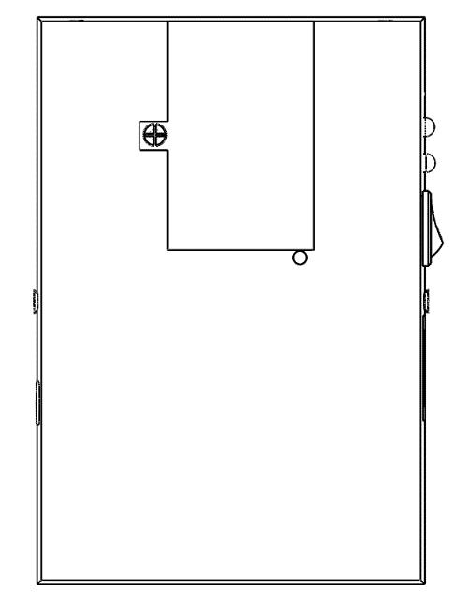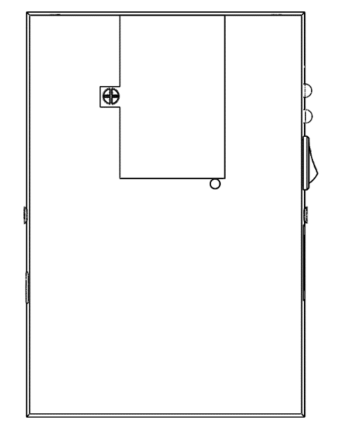

1. Turn counter clock-wise

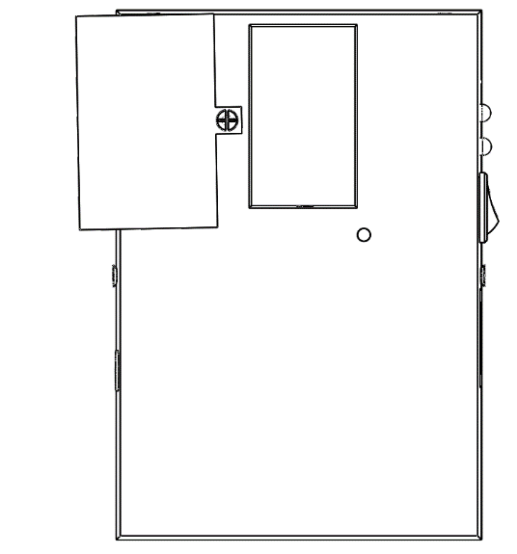

*Battery Performance*

With the fully functions activated, a ***full-charged battery can last min. of 2 days***. When the LEDs change to red, should replace the battery. Otherwise the units will not be functioning as required.

Set the data manually on to the display unit:

1. <write the way the thresholds can be input >

Now the product is ready to measure the environment conditions and function at its full capacity.

1. **Getting to know your product**

Sensor Unit

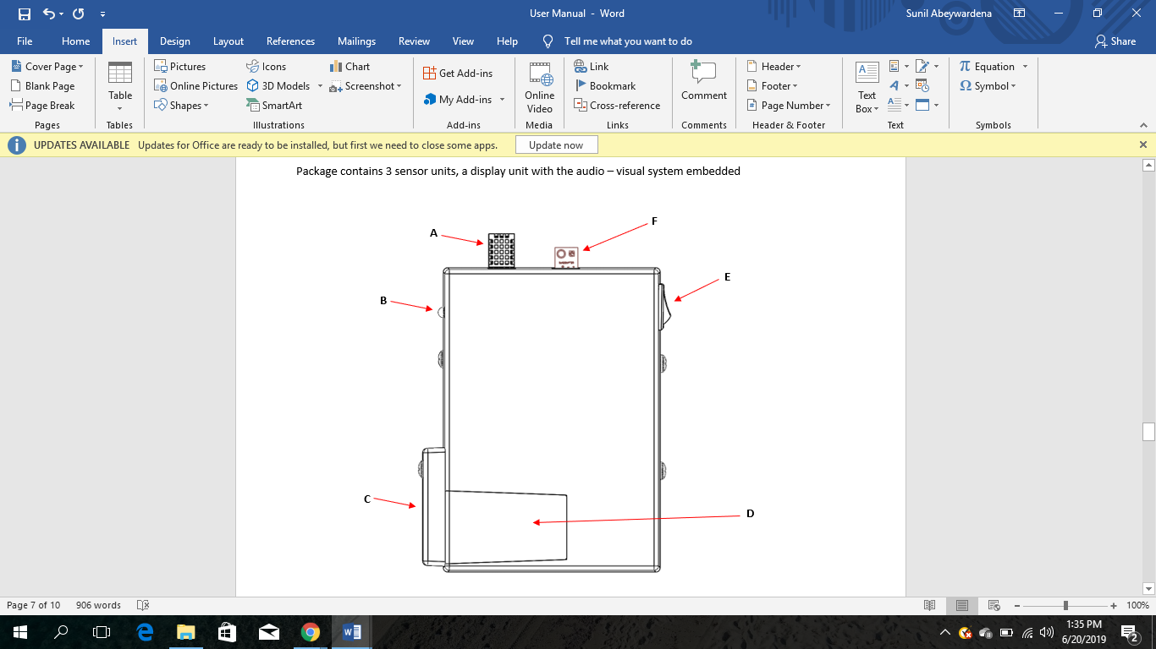

**A: RH and temperature sensor**

Measures the relative humidity of the air inside the environment you are monitoring and the temperature of it.

**B: Battery Level Indicator LEDs**

Green and red LEDs are set up here. Green LED is on when the battery voltage is higher than 6.8V and red when its lower than 6.8V. Both will be turned off when the battery level drops to 4V.

**C: Battery Lever**

**D: Battery Cover**

**E: Switch**

Turn on and off the entire sensor unit after the battery is being correctly installed as per section 1

**F: Light Intensity sensor**

This measures the light intensity inside the controlled environment.

Apart from these in-built parts of the sensor unit, the soil moisture sensor will be separately attached to the sensor unit through a connector.

Display Unit

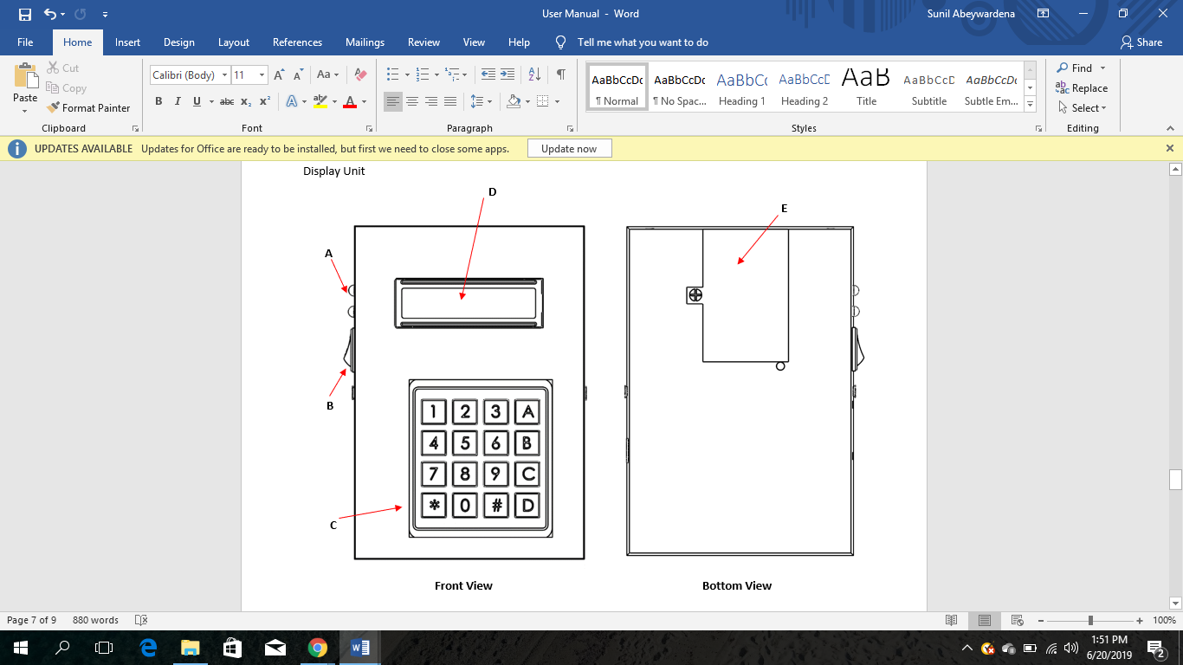

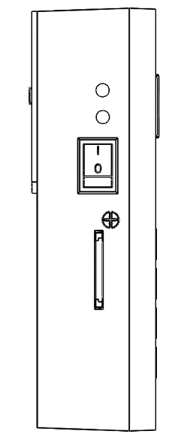

**A**

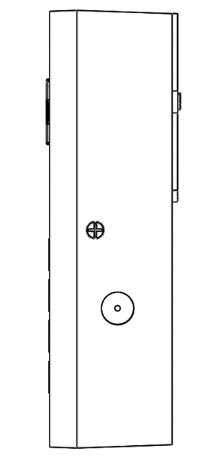

**B**

**G**

**F**

**A: Battery Level Indicator LEDs**

Green and red LEDs are set up here. Green LED is on when the battery voltage is higher than 6.8V and red when its lower than 6.8V. Both will be turned off when the battery level drops to 4V.

**B: Switch**

**C: Keypad**

Can be used to set the threshold values manually, to enter the inputs to display the environment condition values one by one on the LCD display and turn on the LCD screen

**D: LCD Screen**

Shows the requested values from the key pad.

**E: Battery Cover**

**F: Buzzer**

This is internally triggered to alarm the users that the conditions inside the controlled environment has gone to a undesired state

**G: Micro SD Card slot**

Use to insert the micro SD card through here and get the values saved.

1. **Using the product**

Sensor Unit

1. Switch the sensor unit on/off using the switch in the side of the sensor unit
2. Replace the battery when the red LED lights up
3. If the two LEDs are switched off first try replacing the battery. If it does not light up the Green LED, contact an agent from our company.

Display Unit

1. Switch the display unit on/off using the switch on the side of the display unit
2. Setting the Thresholds
   1. Choosing the environmental condition to which the threshold should be set

How???????????

* 1. Setting the threshold to the environmental condition threshold

How???????????

1. Setting the Alarm On/Off
   1. Alarm On

There is no option given to set the alarm inside manually. It gets On once at least one of the environmental conditions exceed the set threshold values.

* 1. Alarm Off

Once the alarm is triggered, it will keep on with some refreshing periods until the condition is being rectified or manually switching the alarm off. Once the alarm is set off, the unit will wait 1 min and check the condition inside the controlled environment and if the condition persists again the alarm will be triggered. ******* WHAT BUTTON TO BE PRESSED TO SWITCH OFF THE ALARM ********

1. Getting the data on to the Micro SD card

Insert the Micro SD card to the Micro SD card slot

The values received from the sensor units will be written in the SD card periodically with a period of 10mins. *******CAN THIS BE SET MANUALLY ON KEYBOARD*******

1. Displaying the values received on the LCD screen
   1. Selecting the sensor unit out of the three sensor units connected

********HOW********

* 1. Selecting the environmental condition to be displayed

*******HOW *********